190905104
Parth Shukla
Lab 5

Write a recursive descent parser for the following simple grammars:

Q1) S -> a | > | (T)
T -> T,S | S

After removing left recursion,

S -> a | > | (T)
T -> ST’
T’ -> ,ST’ | E

(Note: E is epsilon)

/*
S -> a | > | (T)
T -> T,S | S

After removing left recursion,

S -> a | > | (T)
T -> ST’
T’ -> ,ST’ | E
*/

#include <stdlib.h>
#include <stdio.h>
#include <string.h>

int cur = 0;
char s[1000];

void S();
void T();
void Tprime();

void invalid(){
printf("----------------ERROR!----------------\n");
exit(0);
}

void valid(){
printf("------------------SUCCESS!------------------\n");
exit(0);
}

void S(){
if(s[cur] == 'a' || s[cur] == '<'){
cur++;
return;
}
else if(s[cur] == '('){
cur++;
T();
if(s[cur] == ')'){
cur++;
return;
}
else{
invalid();
}
}
else{
invalid();
}
}

void T(){
S();
Tprime();
}

void Tprime(){
if(s[cur] == ','){
cur++;
S();
Tprime();
}
}

void main(){
printf("Enter string:\n");
scanf("%s",s);
S();
if(s[cur] == '$')
valid();
else
invalid();
}

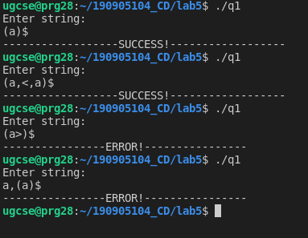

2) S -> UVW
U -> (S) | aSb | d
V -> aV | E
W -> cW | E

/*
S->UVW
U->(S) | aSb | d
V -> aV | empty
W -> cW | empty
*/

#include <stdio.h>
#include <stdlib.h>
#include <string.h>

int cur = 0;
char s[1000];

void invalid(){
printf("------------------ERROR!------------------\n");
exit(0);
}

void valid(){
printf("------------------SUCCESS!------------------\n");
exit(0);
}

void S();
void U();
void V();
void W();

void S(){
U();
V();
W();
}
void U(){
if(s[cur] == '('){
cur++;
S();
if(s[cur] == ')'){
cur++;
return;
}
else invalid();
}
else if(s[cur] == 'd'){
cur++;
return;
}
else if(s[cur] == 'a'){
cur++;
S();
if(s[cur] == 'b'){
cur++;
return;
}
else invalid();
}
else invalid();
}

void V(){
if(s[cur] == 'a'){
cur++;
V();
}
}

void W(){
if(s[cur] == 'c'){
cur++;
W();
}
}

void main(){
printf("Enter string:\n");
scanf("%s",s);
S();
if(s[cur] == '$')
valid();
else
invalid();
}

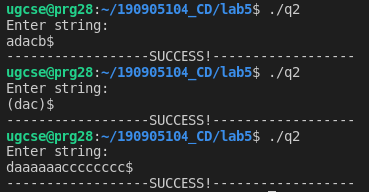

3) S -> aAcBe
A -> Ab | b
B -> d

After eliminating left recursion,
S -> aAcBe
A -> bA’
A’ -> bA’ | E
B -> d

/*
S -> aAcBe
A -> Ab | b
B -> d

After eliminating left recursion,
S -> aAcBe
A -> bA’
A’ -> bA’ | E
B -> d
*/

#include <stdio.h>
#include <stdlib.h>
#include <string.h>

int cur = 0;
char s[1000];

void S();
void A();
void Aprime();
void B();

void invalid(){
printf("------------------ERROR!------------------\n");
exit(0);
}

void valid(){
printf("------------------SUCCESS!------------------\n");
exit(0);
}

void S(){
if(s[cur] == 'a'){
cur++;
A();
if(s[cur] == 'c'){
cur++;
B();
if(s[cur] == 'e'){
cur++;
return;
}
else{
invalid();
}
}
else{
invalid();
}
}
else{
invalid();
}
}

void A(){
if(s[cur] == 'b'){
cur++;
Aprime();
}
else{
invalid();
}
}

void Aprime(){
if(s[cur] == 'b'){
cur++;
Aprime();
}
}

void B(){
if(s[cur] == 'd'){
cur++;
return;
}
else{
invalid();
}
}

void main(){
printf("Enter string:\n");
scanf("%s",s);
S();
if(s[cur] == '$')
valid();
else
invalid();
}
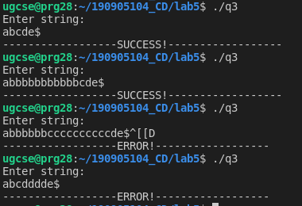

4) S -> (L) | a
L -> L,S | S

After removing left recursion,

S -> (L) | a
L -> SL’
L’ -> ,SL’ | E

/*S -> (L) | a
L -> L,S | S

After removing left recursion,

S -> (L) | a
L -> SL’
L’ -> ,SL’ | E
*/

#include <stdio.h>
#include <stdlib.h>
#include <string.h>

int cur = 0;
char s[1000];

void S();
void L();
void Lprime();

void invalid(){
printf("------------------ERROR!------------------\n");
exit(0);
}

void valid(){
printf("------------------SUCCESS!------------------\n");
exit(0);
}

void S(){
if(s[cur] == '('){
cur++;
L();
if(s[cur] == ')'){
cur++;
return;
}
else{
invalid();
}
}
else if(s[cur] == 'a'){
cur++;
return;
}
else{
invalid();
}
}

void L(){
S();
Lprime();
}

void Lprime(){
if(s[cur] == ','){
cur++;
S();
Lprime();
}
}

void main(){
printf("Enter string:\n");
scanf("%s",s);
S();
if(s[cur] == '$')
valid();
else
invalid();
}

